TCS - CENTRA

Textile

Requirement Document

(Version 17.24)

September 20, 2023

**Lingaasys PRIVATE LIMITED**

**Table Of Contents**

Contents

1 Introduction 4

2 Login Screen 4

**Documentation identification:**

|  |  |
| --- | --- |
| Property | The Chennai silks (TCS) |
| Title: | TCS CENTRA |
| Subject: | Requirement Document |
| Version: | 17.24 |
| Sign Off Date: |  |
| Author(s): | Balaji N |

**Revision History:**

|  |  |  |  |  |  |
| --- | --- | --- | --- | --- | --- |
| Version | Issue Date | Created By | Revision Detail | Reviewed By | Reviewed Date |
| 17.24 |  | TCS BA Team |  |  |  |

# Introduction

The document is intended to document the business requirement, business rules and understanding of user expectations for Requirements.

## Login Screen

### 2.1 Login Screen Functional Specification

|  |  |
| --- | --- |
| **Sub-Topic** | **Description** |
| Use Case Name | Login Screen |
| User Roles | Textile User/Non – Textile User/ Administrator |
| Description | This use case is for login to the system |
| Precondition | User must go to the tcs centra url of the system with the full access right to this function |
| Post Condition | User must navigate to the tcs centra dashboard |
| Basic Flow | * User should able to select their user roles from the user role dropdown * Based on selection of user role background of login screen color should be change * User should able to enter their user code in that field * User should able to enter their password in that field * Both user code and password fields should not shows the entered data * User should login with valid credentials, Otherwise should through validation message * If user is absent at the day none of them should not able to login to the system * User should navigate to the homepage of tcs centra * User should not allow to perform copy, cut, paste functions in the each page * User should able to clear the entered text by click on the cancel button * User should able to close the login screen by click on the exit button |

### 

### **2.2 Login Screen Wireframe**

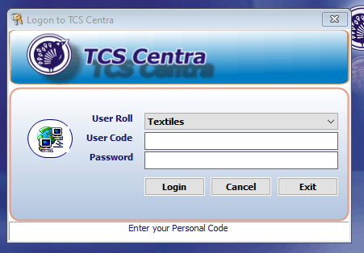

### 

### **2.3 Login Screen Field Specification**

|  |  |  |  |  |  |  |
| --- | --- | --- | --- | --- | --- | --- |
| **S.No** | **Field Name** | **Value** | **Data Type** | **Length** | **Control Type** | **Mandatory (Y/N)** |
|  |  |  |  |  |  |  |
|  |  |  |  |  |  |  |
|  |  |  |  |  |  |  |
|  |  |  |  |  |  |  |
|  |  |  |  |  |  |  |

## Supplier Master Form

### 3.1 Supplier Master Form Functional Specification

|  |  |
| --- | --- |
| **Sub-Topic** | **Description** |
| Use Case Name | Supplier Master Form - Create |
| User Roles | Textile User |
| Description | This use case is for supplier master form is to create a new supplier of the system |
| Precondition | User must login to the system with the full access right to this function |
| Post Condition | NA |
| Basic Flow | * User should use ctrl + N key to create an New supplier * In the Code field it should be generate auto code and should not be non-editable field * User should able to enter their user code in that field * User should able to enter their password in that field * Both user code and password fields should not shows the entered data * User should login with valid credentials, Otherwise should through validation message * If user is absent at the day none of them should not able to login to the system * User should navigate to the homepage of tcs centra * User should not allow to perform copy, cut, paste functions in the each page * User should able to clear the entered text by click on the cancel button * User should able to close the login screen by click on the exit button |